EXP:2
Implement a C Program to Check for a valid String
AIM:
Check whether an input string contains only alphabetic letters (A–Z, a–z).
ALGORITHM:
- Read the input string.
- For each character check if it is an alphabet or space.
- If any non-alphabet (except space) found mark invalid and break.
- Print Valid if all characters are letters/spaces else print Invalid.
PROGRAM:
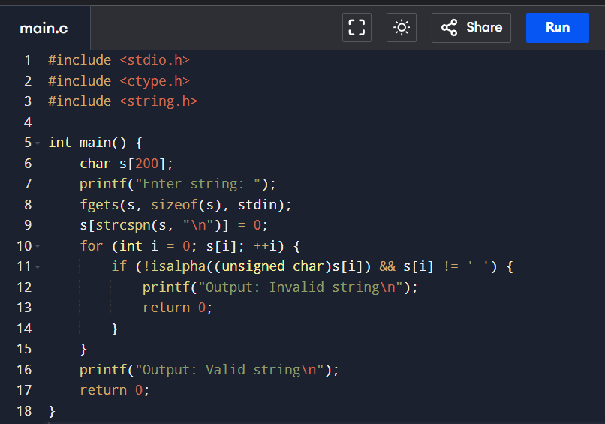
OUTPUT:
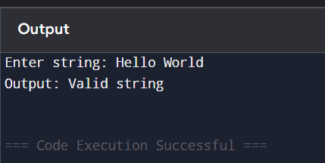
RESULT:
Program verifies string contains only letters/spaces.

